**Experiment 03: Cyclic Redundancy Check Code**

***Sender Side Code***

#include<iostream>

#include<bits/stdc++.h>

using namespace std;

class DataStream

{

public:

int n; ///Number of bits in data

int k; ///Number of bits in g(x)

vector<int> data;

vector<int> gx;

DataStream(int n,int k,vector<int> data,vector<int> gx)

{

this->n=n;

this->k=k;

this->data=data;

this->gx=gx;

cout<<"\n____Initialisation Data___"<<endl;

cout<<"Data: ";

for(int i=0; i<n; i++) {cout<<data[i]<<" ";}

cout<<endl;

cout<<"G(X): ";

for(int i=0; i<k; i++){ cout<<gx[i]<<" ";}

cout<<endl;

}

};

class CodeWord:public DataStream

{

public:

vector<int> quot;

vector<int> curr_divident;

CodeWord(int n,int k,vector<int> data,vector<int> gx):DataStream(n,k,data,gx)

{

vector<int> temp(data.begin(),data.begin()+k);

curr_divident=temp;

AppendBits();

}

void AppendBits()

{

for(int i=0; i<k-1; i++)

{

data.push_back(0);

}

cout<<"\n___After appending "<<k-1<<" 0s to data___"<<endl;

cout<<"Updated Data: ";

for(int i=0; i<data.size(); i++){cout<<data[i]<<" ";}

cout<<endl;

}

void FormCodeWord()

{

int j=0;

for(int i=n; i<data.size(); i++)

{data[i]=curr_divident[j++];}

cout<<"\nRemainder after division i.e CRC is: ";

for(int i=0;i<curr_divident.size();i++){

cout<<curr_divident[i]<<" ";

}

cout<<"\n\n___Data sent to receiver___"<<endl;

cout<<"CODE WORD IS: ";

for(int i=0; i<data.size(); i++) cout<<data[i]<<" ";

cout<<endl;

}

void Divide()

{

int special_break=0;

int nextbit=k;

while(nextbit<data.size())

{

/// => If data[0] i.e first bit is NOT 1 it's not divisible

/// => Append 0 to quototient and update the divident before xoring

if(curr_divident[0]==0)

{

quot.push_back(0);

///Remove first bit

curr_divident.erase(curr_divident.begin(),curr_divident.begin()+1);

///Push the next bit into divident

curr_divident.push_back(data[nextbit++]);

///Continue xoring AS WE HAVE UPDATED the divident already

}

/// => Xor each element of divident

for(int i=0; i<k; i++)curr_divident[i]=(curr_divident[i]^gx[i]);

quot.push_back(1);

///Remove first bit

curr_divident.erase(curr_divident.begin(),curr_divident.begin()+1);

if(nextbit==data.size())

{

special_break=1;

break;

}

curr_divident.push_back(data[nextbit++]);

}

if(!special_break) curr_divident.erase(curr_divident.begin(),curr_divident.begin()+1);

///_________________FORM THE CODE WORD___________________

FormCodeWord();

}

};

int main()

{

int n,k,bit;

vector<int> data,gx;

cout<<"Enter the number of bits in data: ";

cin>>n;

cout<<"Enter the number of bits in g(x): ";

cin>>k;

cout<<"Enter the data stream to be sent: ";

for(int i=0; i<n; i++)

{ cin>>bit;

data.push_back(bit);

}

cout<<"Enter the g(x) stream: ";

for(int i=0; i<k; i++)

{ cin>>bit;

gx.push_back(bit);

}

CodeWord *c1=new CodeWord(n,k,data,gx);

c1->Divide();

return 0;

}

***Output***

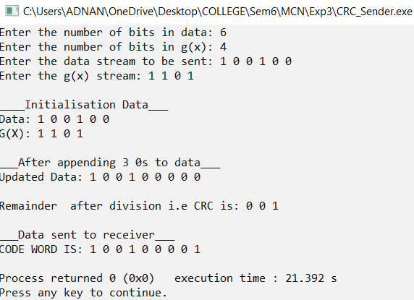

***Receiver Side Code:***

#include<iostream>

#include<bits/stdc++.h>

using namespace std;

class DataStream

{

public:

int n; ///Number of bits in data

int k; ///Number of bits in g(x)

vector<int> data;

vector<int> gx;

DataStream(int n,int k,vector<int> data,vector<int> gx)

{

this->n=n;

this->k=k;

this->data=data;

this->gx=gx;

cout<<"\n____Data Received [Code Word] is___"<<endl;

cout<<"Data: ";

for(int i=0; i<n; i++) {cout<<data[i]<<" ";}

cout<<endl;

cout<<"G(X): ";

for(int i=0; i<k; i++){ cout<<gx[i]<<" ";}

cout<<endl;

}

};

class CodeWord:public DataStream

{

public:

vector<int> quot;

vector<int> curr_divident;

CodeWord(int n,int k,vector<int> data,vector<int> gx):DataStream(n,k,data,gx)

{

vector<int> temp(data.begin(),data.begin()+k);

curr_divident=temp;

}

void Verify()

{

bool no_error=true;

cout<<"\n_____C O N C L U S I O N_____\nRemainder obntained after division is: "<<endl;

for(int i=0;i<curr_divident.size();i++){

cout<<curr_divident[i]<<" ";

}

cout<<endl;

for(int i=0;i<curr_divident.size();i++){

int bit=curr_divident[i];

if(bit!=0){

no_error=false;

cout<<"Remainder Obtained is NOT zero || Hence ask sender to resend the data"<<endl;

}

}

if(no_error){

cout<<"\nData received without any ERROR"<<endl;

cout<<"\nActual Data is: ";

for(int i=0;i<data.size()-curr_divident.size();i++){

cout<<data[i]<<" ";

}

}

}

void Divide()

{

int special_break=0;

int nextbit=k;

/// => Iterate till no bits are left in data to be appended

while(nextbit<data.size())

{

/// => If data[0] i.e first bit is NOT 1 it's not divisible

/// => Append 0 to quototient and update the divident before xoring

if(curr_divident[0]==0)

{

quot.push_back(0);

///Remove first bit

curr_divident.erase(curr_divident.begin(),curr_divident.begin()+1);

///Push the next bit into divident

curr_divident.push_back(data[nextbit++]);

///Continue xoring AS WE HAVE UPDATED the divident already

}

/// => Xor each element of divident

for(int i=0; i<k; i++)curr_divident[i]=(curr_divident[i]^gx[i]);

quot.push_back(1);

///Remove first bit

curr_divident.erase(curr_divident.begin(),curr_divident.begin()+1);

/// => Applied only when next bit has reach size at which there is no further bit to append

if(nextbit==data.size())

{

special_break=1;

break;

}

///Push the next bit into divident

curr_divident.push_back(data[nextbit++]);

}

/// => ELIMINATE the first bit, remainig bits is remainder as we need [K-1] bits only

if(!special_break) curr_divident.erase(curr_divident.begin(),curr_divident.begin()+1);

///_________________VERIFY FROM REMAINDER___________________

Verify();

}

};

int main()

{

int n,k,bit;

vector<int> data,gx;

cout<<"Enter the number of bits in received code word: ";

cin>>n;

cout<<"Enter the number of bits in g(x): ";

cin>>k;

cout<<"Enter the code word received: ";

for(int i=0; i<n; i++)

{ cin>>bit;

data.push_back(bit);

}

cout<<"Enter the g(x) stream: ";

for(int i=0; i<k; i++)

{ cin>>bit;

gx.push_back(bit);

}

CodeWord *c1=new CodeWord(n,k,data,gx);

c1->Divide();

return 0;

}

***Output:***

***Case 01: Without Error in Code Word***

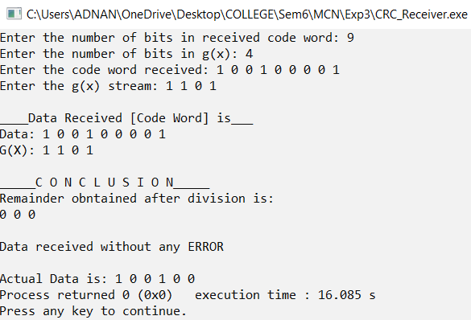

***Case 01: With Error in Code Word***

